Information for public sector organisations

Good Privacy Everyday
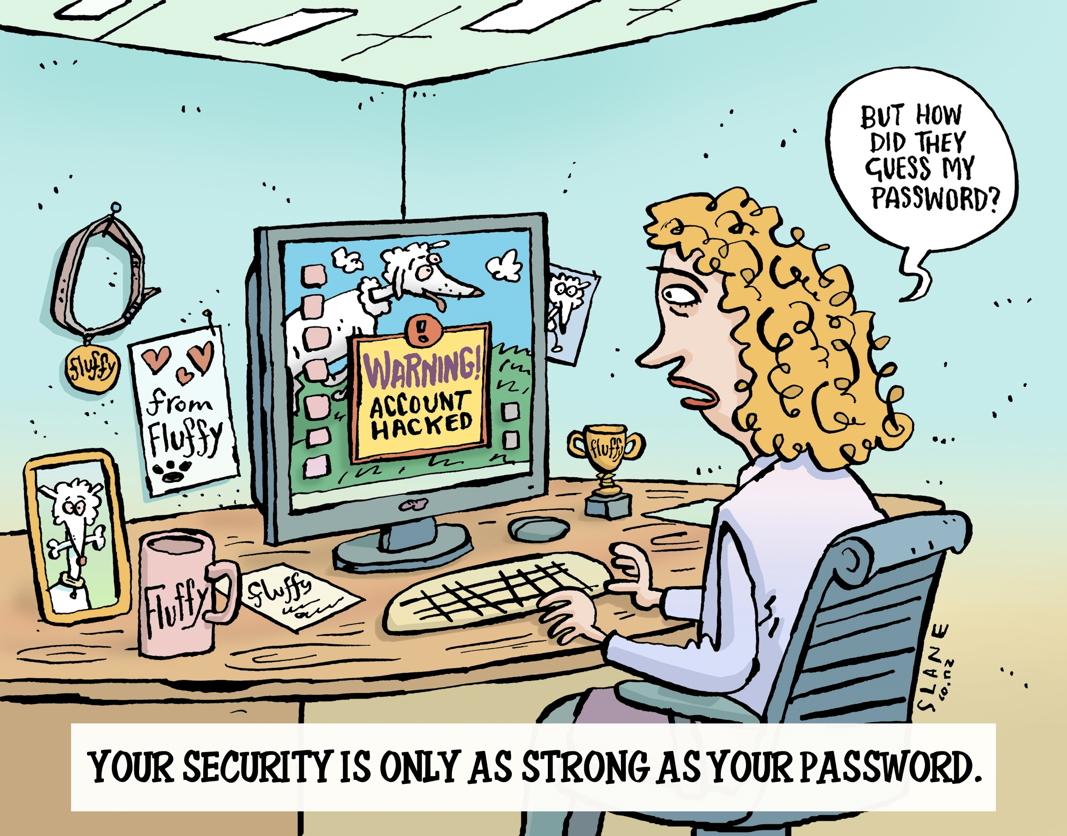
Guidance for Northern Territory
public sector organisations

NT public sector organisations have obligations to protect the personal information of individuals. Protecting privacy is important for a number of reasons. It can help to build trust between government and the public and contribute to good business practices.

Tips for good privacy practice
Here are some practical tips that you can implement in your organisation to ensure everyday good privacy. It is important that every employee is aware of their obligations – protecting privacy is everyone’s responsibility.
- Privacy and security are different concepts, but they are related; good security is critical to good privacy.
- Think carefully about whether you need hardcopies of documents containing personal information. If you have an electronic copy for your records, it is best to dispose of hardcopies, so you don’t risk a privacy breach.
- Assess whether there is a need to collect personal information from others as part of a project or initiative. If the personal information is not necessary, you shouldn’t collect it.
- Ensure your computer screen is locked before leaving your desk unattended.
- Have a clear desk policy in place to make sure that all personal information is out of sight and kept secure. This is different to a ‘clean’ desk policy.
- Check email recipients have been entered correctly before sending emails. Where appropriate, use the BCC field. If you are unsure, ask a colleague to double check for you before you send the email.
- Check whether documents and emails should have a protective marking.
Implementing good privacy practices will help your organisation build trust with its stakeholders. If you have any questions you can contact your Privacy Officer or get in touch with the Office of the Information Commissioner.

For further Information, contact us
Disclaimer
The information in this document is general in nature and does not constitute legal advice
1800 005 610
http://www.infocomm.nt.gov.au
infocomm@nt.gov.au

